Introduction

This write-up refers to the Linked machine. If the machine was based on a real pentest, this should be explicitly stated in this section. If you require support, please open a ticket in the support channel on the Discord server..

Reconnaissance
We start by using nmap to check for open ports.
nmap --min-rate 1000 -v -sVC MACHINE_IP

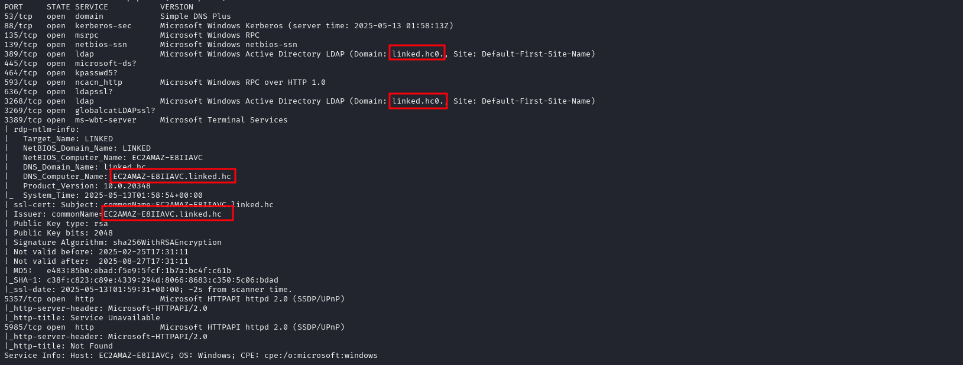Figure 1 - Inserting code block element.

We can use netexec to verify whether pre-authentication with the Guest user is possible, and we see that it is.

Figure 2 - Access denied with empty user.

Figure 3 - Success with guest user.

Since this is possible, we can use the –rid-brute flag to brute force RIDs, which are only 4 digits. This returns all AD objects.

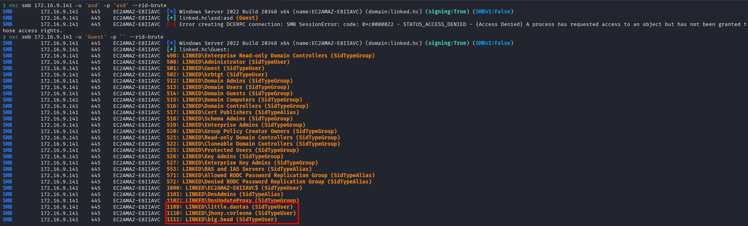Figure 4 - Enumerating Active Directory objects.

Exploitation - obtaining the user flag
With the enumerated users, we can perform an ASREPRoast attack, and we observe that one user is vulnerable.

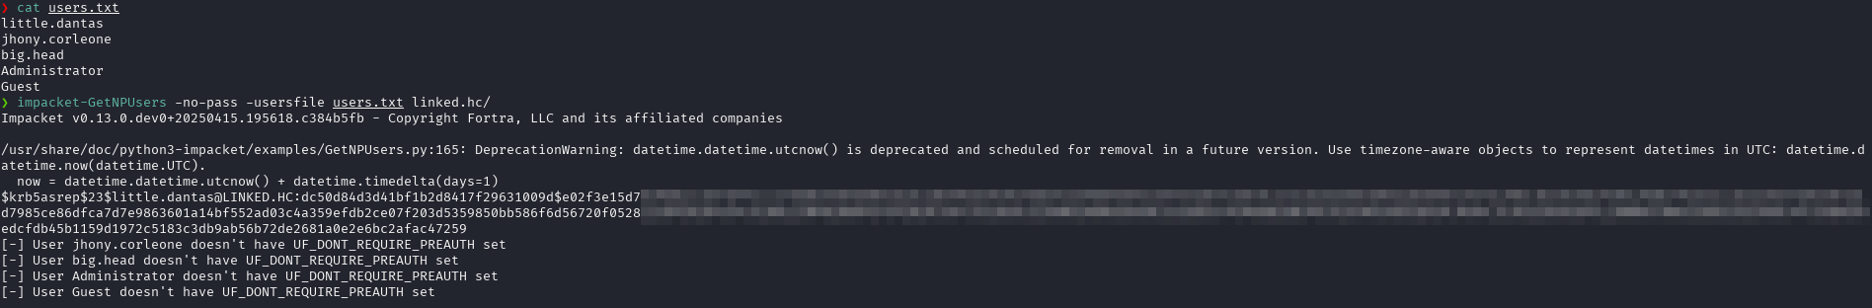Figure 5 - ASREPRoast attack against user little.dantas.

After cracking the hash, we obtain the user’s password, which allows us to access SMB.

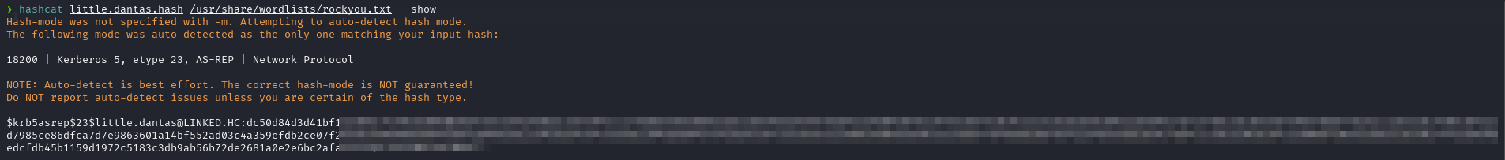
Figure 6 - Hash cracked using hashcat.

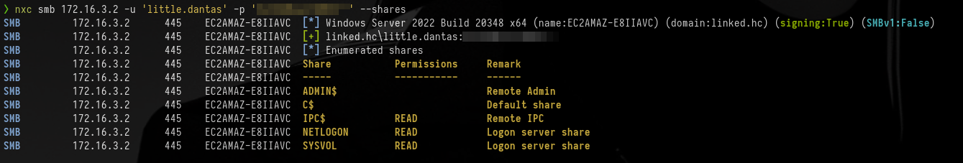Figure 7 - Verifying SMB access.

Accessing SMB with smbclient, we see that inside the linked.hc\scripts folder there is a script called tasklist.vbs. This script simply runs the “tasklist” command as user jhony.corleone using runas. The file contains the user’s credentials.

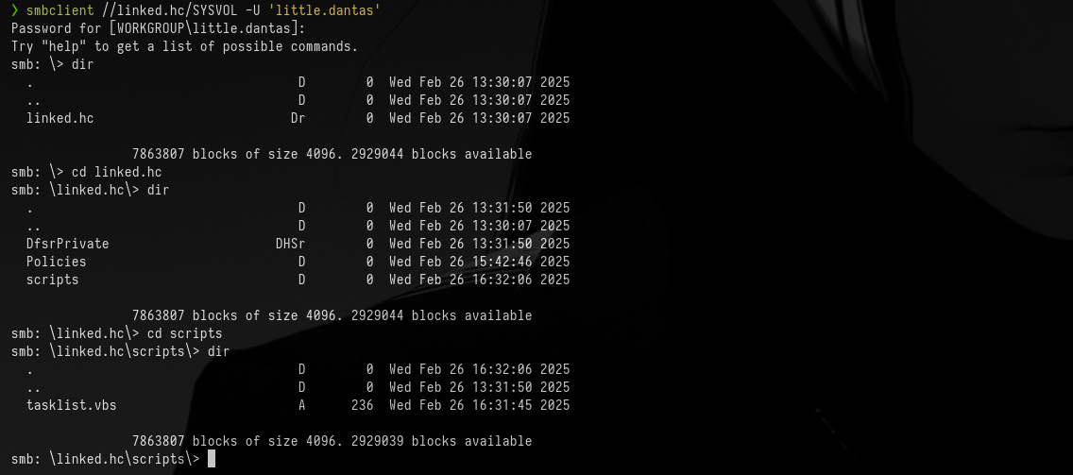Figure 8 - Accessing SMB via smbclient.

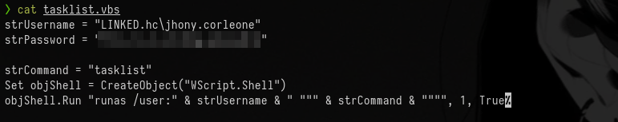Figure 9 - Reading the contents of the tasklist.vbs script.

Using netexec to enumerate this user’s permissions, we see that the user has WinRM access.

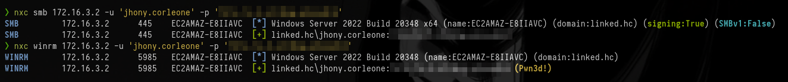Figure 10 - Checking permissions of user jhony.corleone.

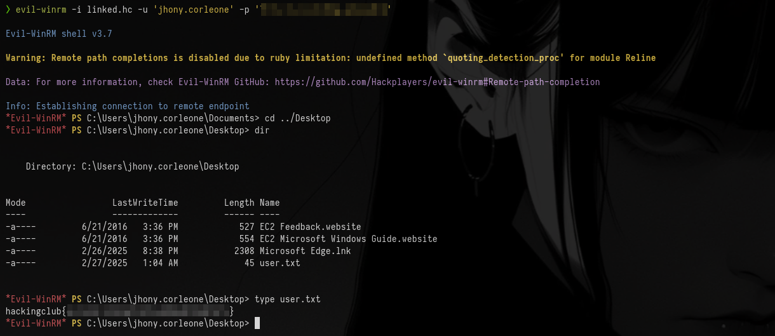Figure 11 - Accessing the user via WinRM and capturing the flag.

Privilege Escalation - obtaining the root flag
After performing extensive enumeration as this user, we run winPEAS and discover a file named Unattended.xml. This file is standard in Windows environments when Panther is configured to perform updates without Administrator interaction. To accomplish this, it stores a username and password, which are then used to trigger Windows Update.
Figure 12 - Identifying the Unattended.xml file with winPEAS.

We confirm this by reading the file contents.

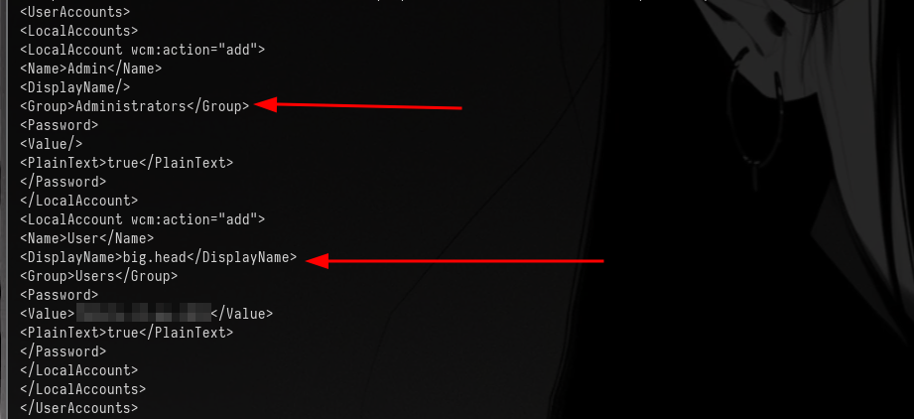Figure 13 - Contents of the Unattended.xml file.

We also observe that the user in question is a member of the Administrators group. Therefore, with access to this account, we gain administrator-level access on the machine.
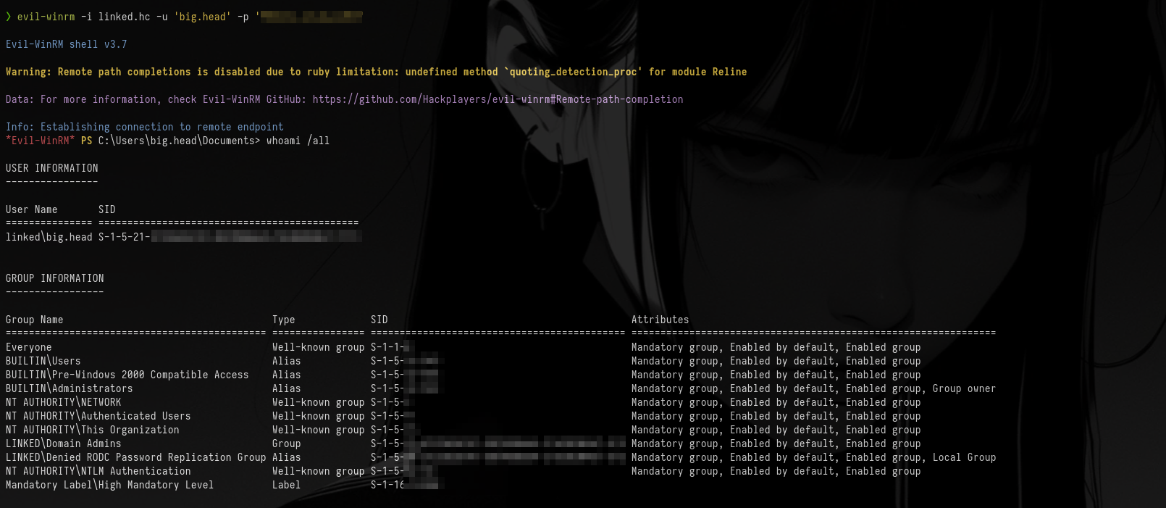Figure 14 - WinRM authentication using user big.head.

With this, we can access the Administrator’s directory and retrieve our final flag.

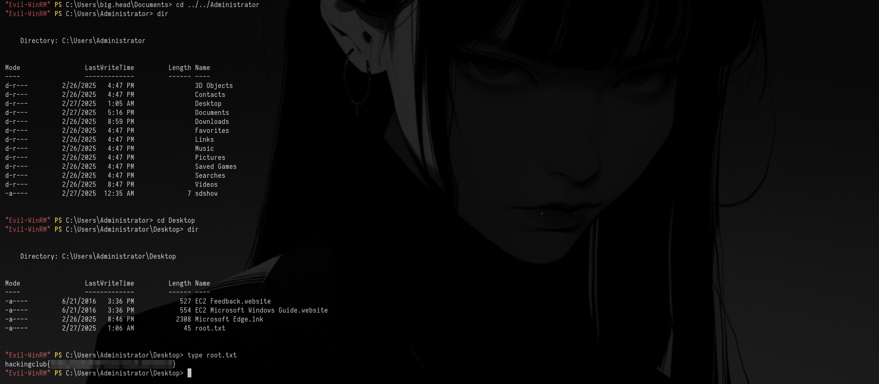Figure 15 - Reading the final flag.

